PROGRAM SUMMARY
This program requires:
- 2 Pins (one from each category: Premera Blog Posts and Premera White Paper)

PREMERA BLOG POSTS: Please select one pin from this category

PIN 1
- Copy: 5 Effective Ways to Build a Successful Team with Tips from Premera Blue Cross #AD
- Copy: Premera Blue Cross and Effective Ways to Build a Successful Team #AD
- URL: https://www.thepositivemom.com/5-effective-ways-to-build-a-successful-team
- Image:
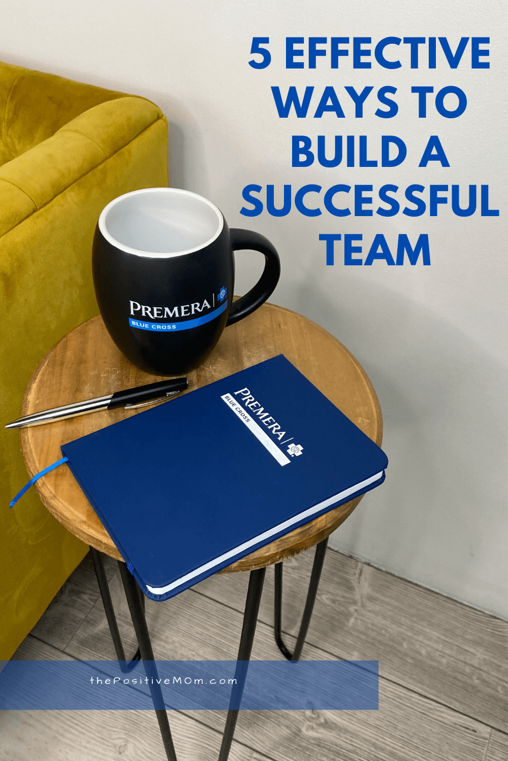

PIN 2
- Copy: How to Grow your Business with Tips from Premera Blue Cross #AD
- Copy: Premera Blue Cross has Tips to Help you Grow Your Business Fast #AD
- URL: https://moderatelyhighmaintenance.com/2-ways-to-grow-your-business-fast-in-2021/
- Image:


PIN 3
- Copy: How to Start a Home Business this Year with Tips from Premera Blue Cross #AD
- Copy: Premera Blue Cross Shares How to Start a Business From Home this Year #AD
- URL: https://project-motherhood.com/how-to-start-a-business-from-home-in-2021-even-when-youre-a-busy-mom/
- Image:


PIN 4
- Copy: Learn How to Grow your Small Business at Home with Premera Blue Cross #AD
- Copy: How to Grow Your Small Business at Home this Year with Tips from Premera Blue Cross #AD
- URL: https://www.busymommymedia.com/how-to-grow-your-small-business-in-2021/
- Image:



PREMERA WHITE PAPER: Please select one pin from this category
PIN 1
- Copy: Premera Blue Cross asked working adults how the pandemic has changed their work and health needs. #AD
- Copy: Premera Blue Cross studied how the pandemic has affected working adults. #AD
- URL: https://business.premera.com/post-pandemic-business-white-paper/?utm_source=Pinterest&utm_medium=infographic&utm_term=1&utm_campaign=2021_b2b_influencer&utm_content=influencer
- Image:

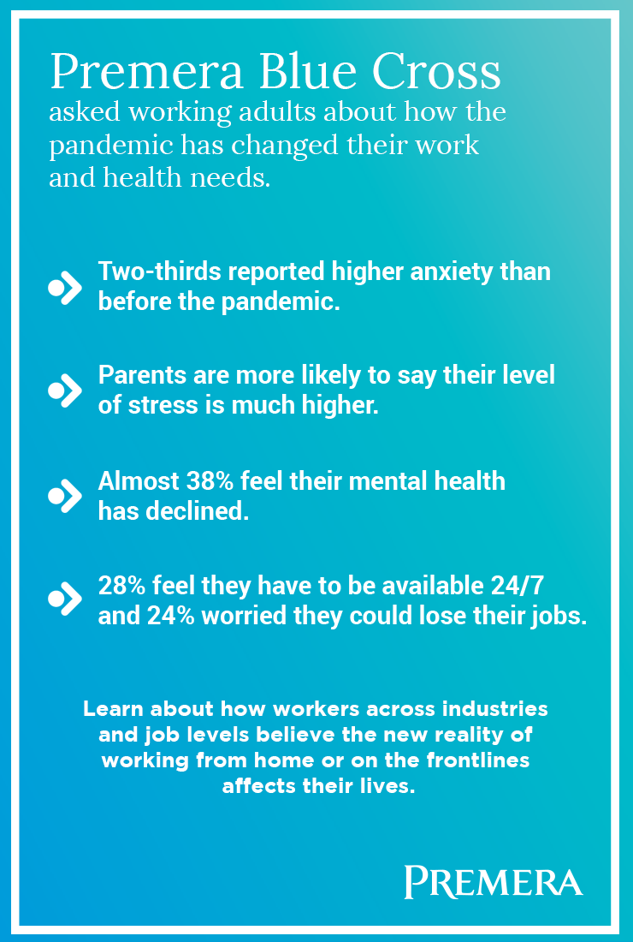
PIN 2
- Copy: Premera Blue Cross shares what they learned about work from home routines this year. #AD
- Copy: See what Premera Blue Cross learned about work from home routines during the pandemic. #AD
- URL: https://business.premera.com/post-pandemic-business-white-paper/?utm_source=Pinterest&utm_medium=infographic&utm_term=1&utm_campaign=2021_b2b_influencer&utm_content=influencer
- Image:
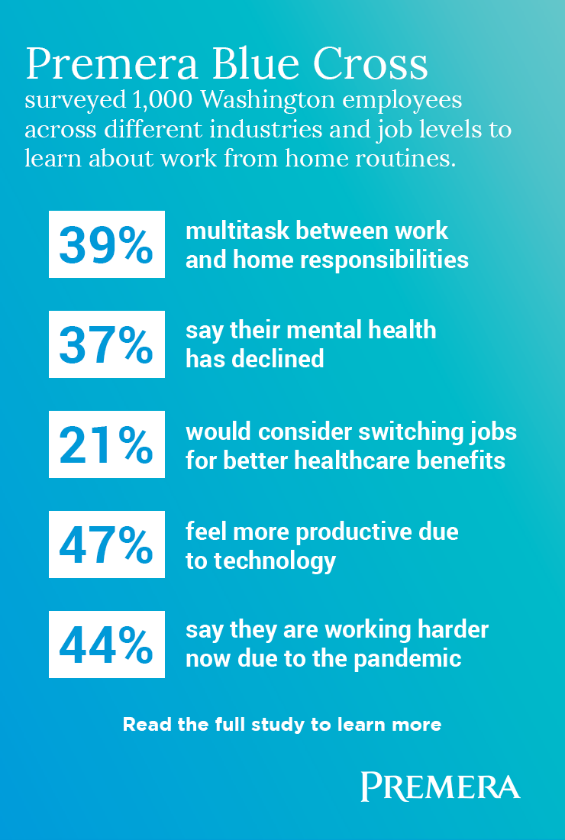
If you have any questions, please feel free to reach out to leah@swaygroup.com.

